Löwner–Heinz theorem

Intro

Statement

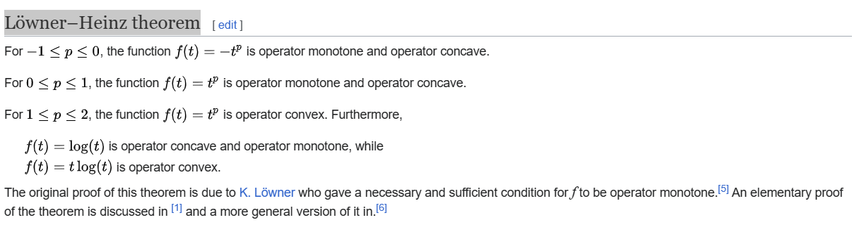

Proof

The author of Wiki says, for proof, see the 1th and 6th link in References section in Wiki.

Ref

[Trace inequality - Wikipedia](https://en.wikipedia.org/wiki/Trace_inequality)